Create and Manage Serverless Functions

Problem Statement:

Now that we have experience with containers and scalable services, we will explore the serverless paradigm. In this lab, we will use AWS Lambda to create, deploy, and manage a simple serverless function. This will demonstrate how to build and run an application without provisioning or managing servers. This lab introduces a new way of thinking about application architecture and will help you understand a critical component of modern DevOps practices.

Tools/Software Versions:

1. Operating System: Amazon Linux 2023 (on EC2)

2. AWS CLI: v2.28.21 or Higher

3. Language Runtime: Node.js 20.x or Python 3.10

4. AWS Service: AWS Lambda

Hands-on Steps:

Step 1: Write a Simple Serverless Function

We'll create a basic function that returns a "Hello, World!" message. This will be the code we deploy to AWS Lambda.

1. Move to your workspace:

cd ~/workspace

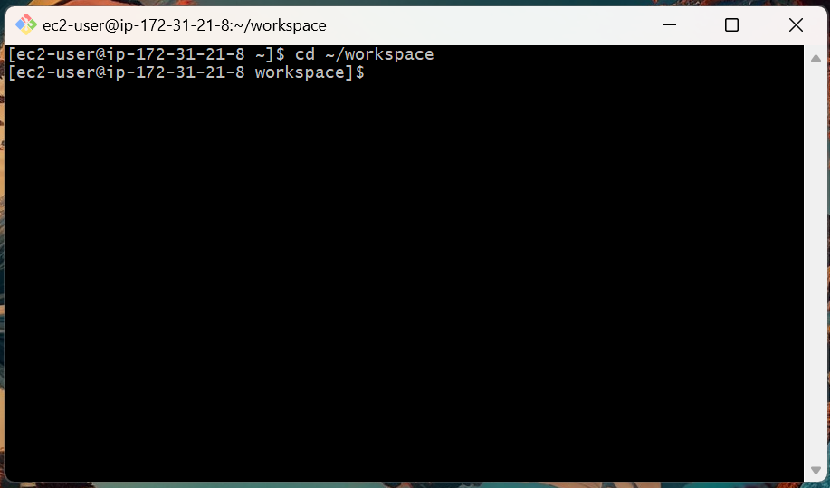

2. Create a new folder for the project:

mkdir serverless-function

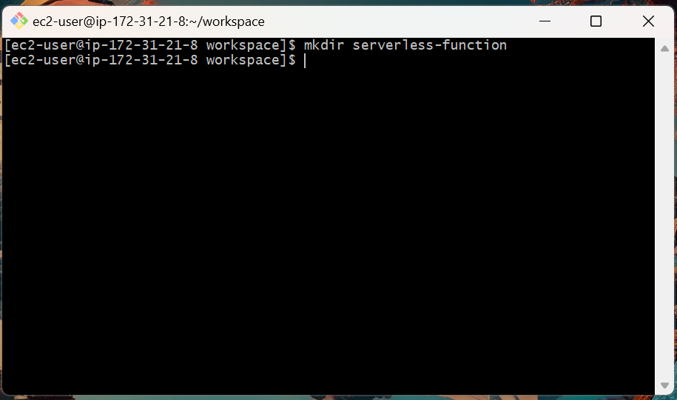

3. Enter the folder:

cd serverless-function

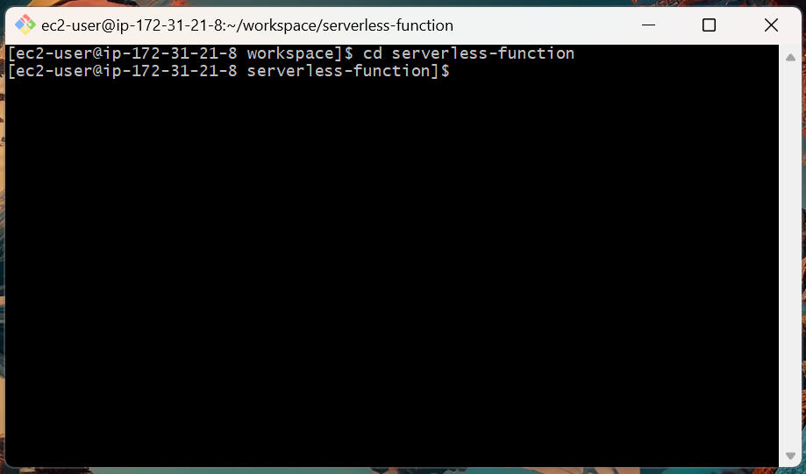

4. Create the function code file. For this example, we'll use Node.js:

nano index.js

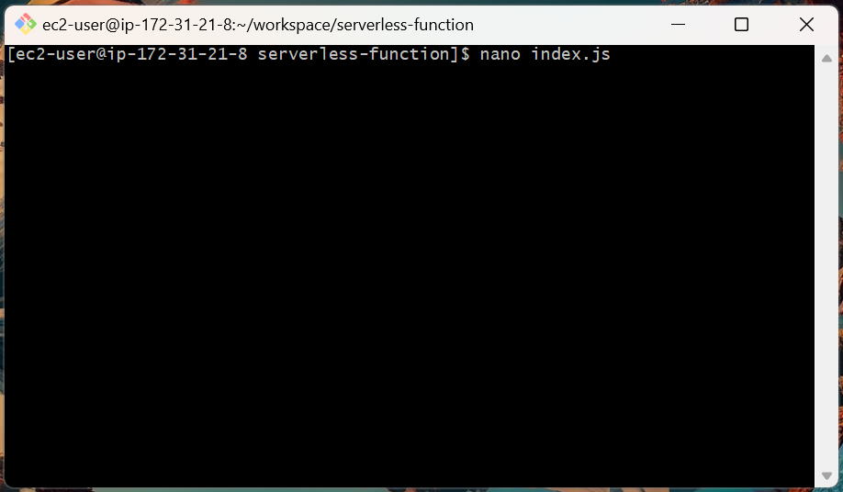

5. Paste the following code into the file:

exports.handler = async (event) => {
const response = {
statusCode: 200,
body: JSON.stringify('Hello, World!'),
};
return response;
};

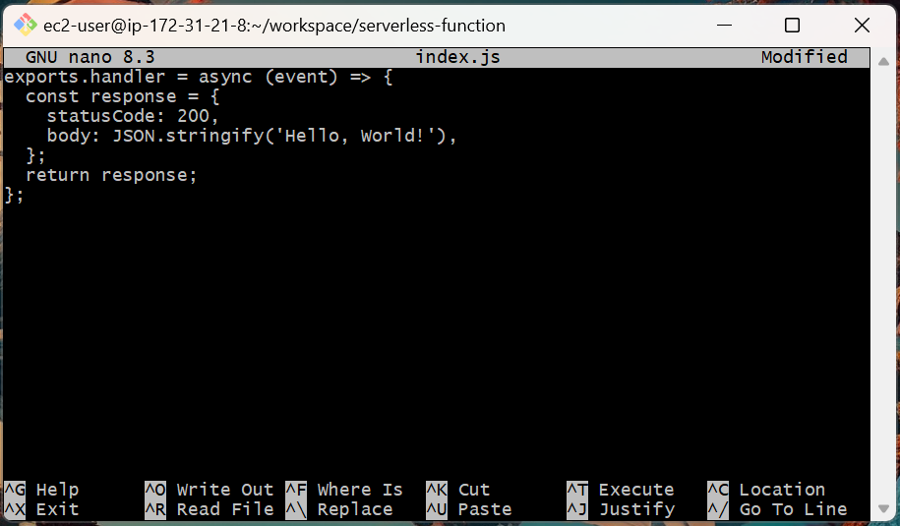

6. Save and exit (CTRL+O, Enter, then CTRL+X).

7. Zip the file to prepare it for upload:

zip function.zip index.js

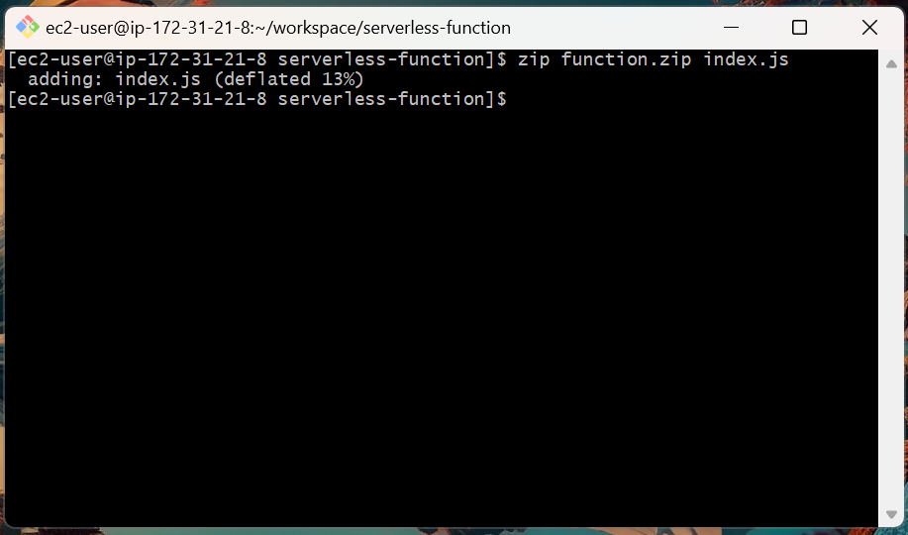

Step 2: Create an IAM Role for AWS Lambda

AWS Lambda functions need an IAM role to grant them permissions to execute and log to CloudWatch.

1. Create a trust policy file for the role:

nano trust-policy.json

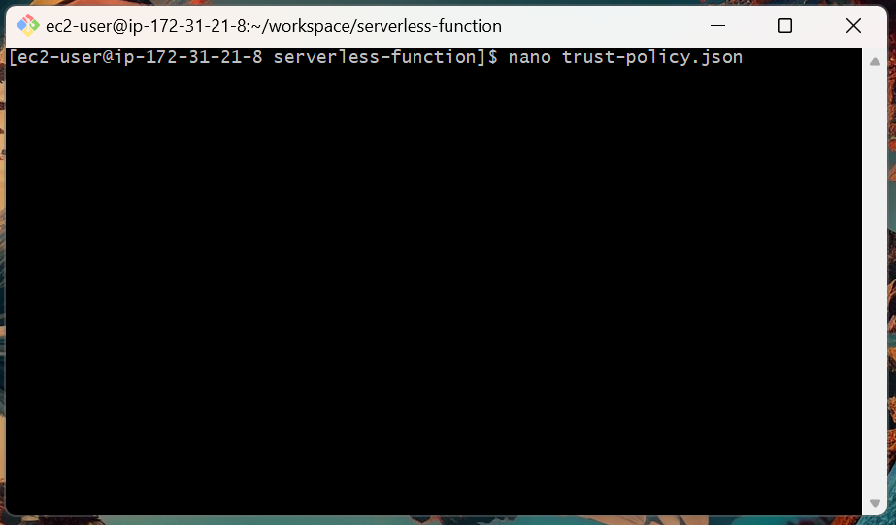

2. Paste this policy, which allows the Lambda service to assume the role:

{
"Version": "2012-10-17",
"Statement": [
{
"Effect": "Allow",
"Principal": {
"Service": "lambda.amazonaws.com"
},
"Action": "sts:AssumeRole"
}
]
}

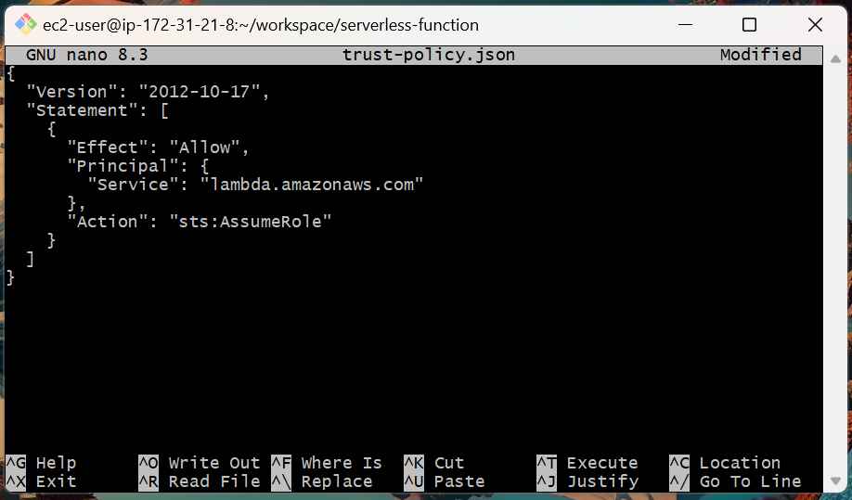

3. Save and exit.

4. Create the IAM role using the trust policy:

aws iam create-role \
--role-name lambda-execution-role \
--assume-role-policy-document file://trust-policy.json

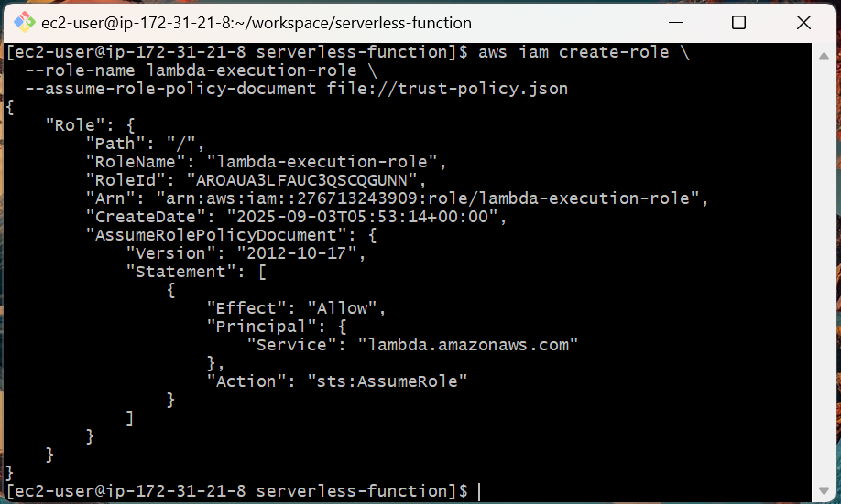

5. Attach the AWS-managed policy for basic Lambda execution permissions:

aws iam attach-role-policy \
--role-name lambda-execution-role \
--policy-arn arn:aws:iam::aws:policy/service-role/AWSLambdaBasicExecutionRole

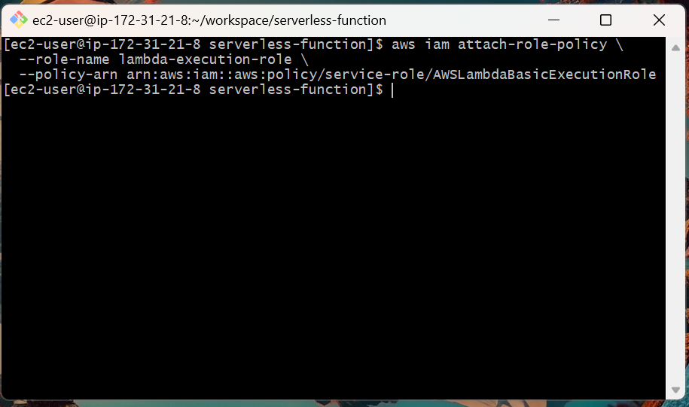

Step 3: Create the AWS Lambda Function

Now we'll use the AWS CLI to create the Lambda function and upload our zipped code.

Use the create-function command:

aws lambda create-function \
--function-name my-first-lambda \
--runtime nodejs20.x \
--role arn:aws:iam::$(aws sts get-caller-identity --query Account --output text):role/lambda-execution-role \
--handler index.handler \
--zip-file fileb://function.zip \
--region ap-south-1

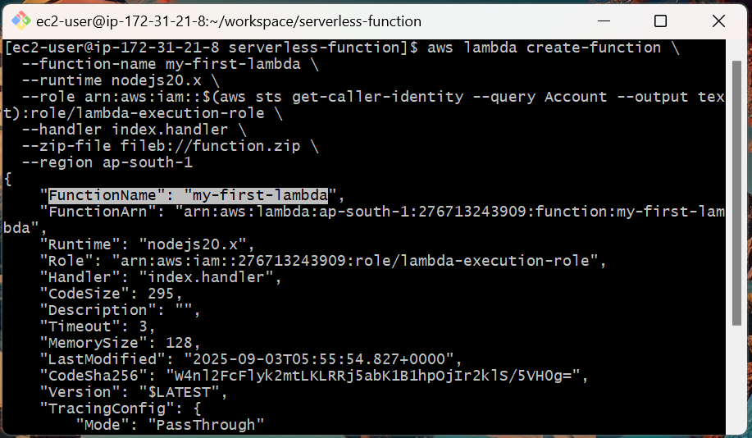

This command specifies the function name, runtime, the IAM role we just created, the handler file (index.js), and our zipped code.

Step 4: Test the Lambda Function

To confirm the function works, we'll invoke it from the command line.

1. Create an event payload file:

nano event.json

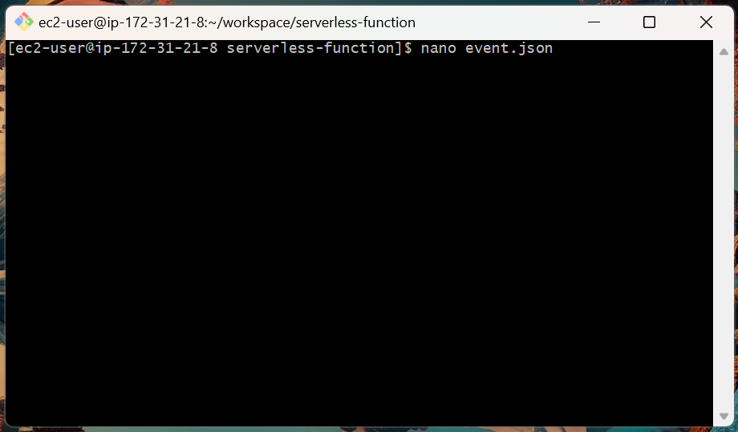

2. Paste a simple JSON object (empty is fine for this example):

{}

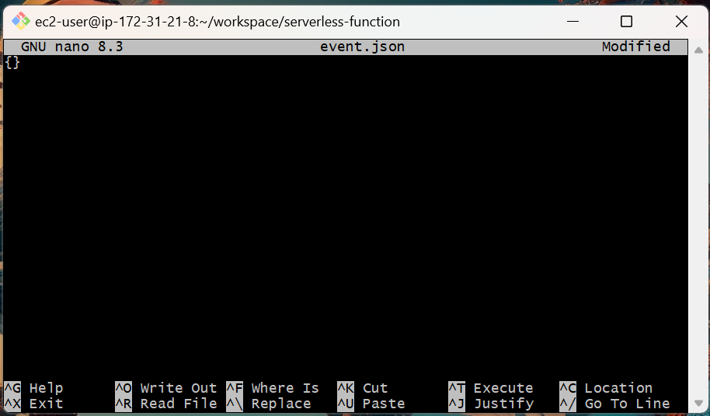

3. Save and exit.

4. Invoke the function using the invoke command:

aws lambda invoke \
--function-name my-first-lambda \
--cli-binary-format raw-in-base64-out \
--payload file://event.json \
output.json

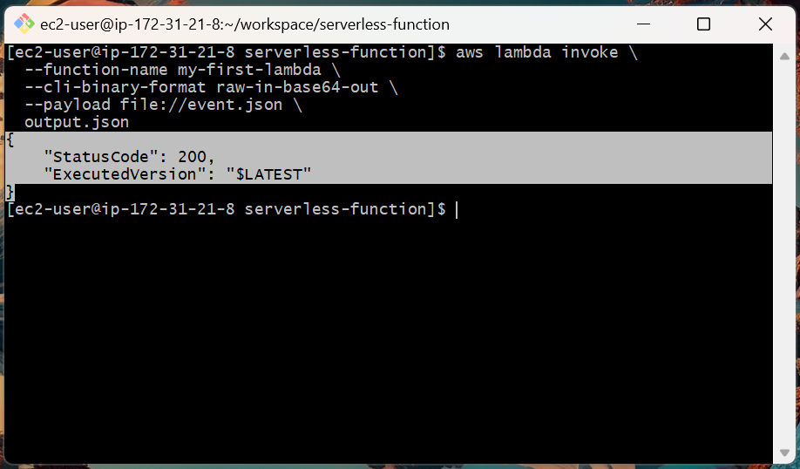

5. Check the output in the output.json file:

cat output.json

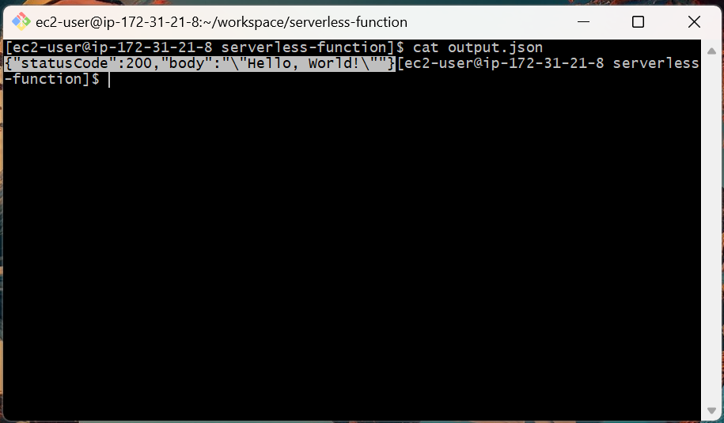

The output should be Hello, World!.

Step 5: View Logs and Metrics

Like with other AWS services, Lambda automatically integrates with CloudWatch for logs and metrics.

1. Open the CloudWatch console.

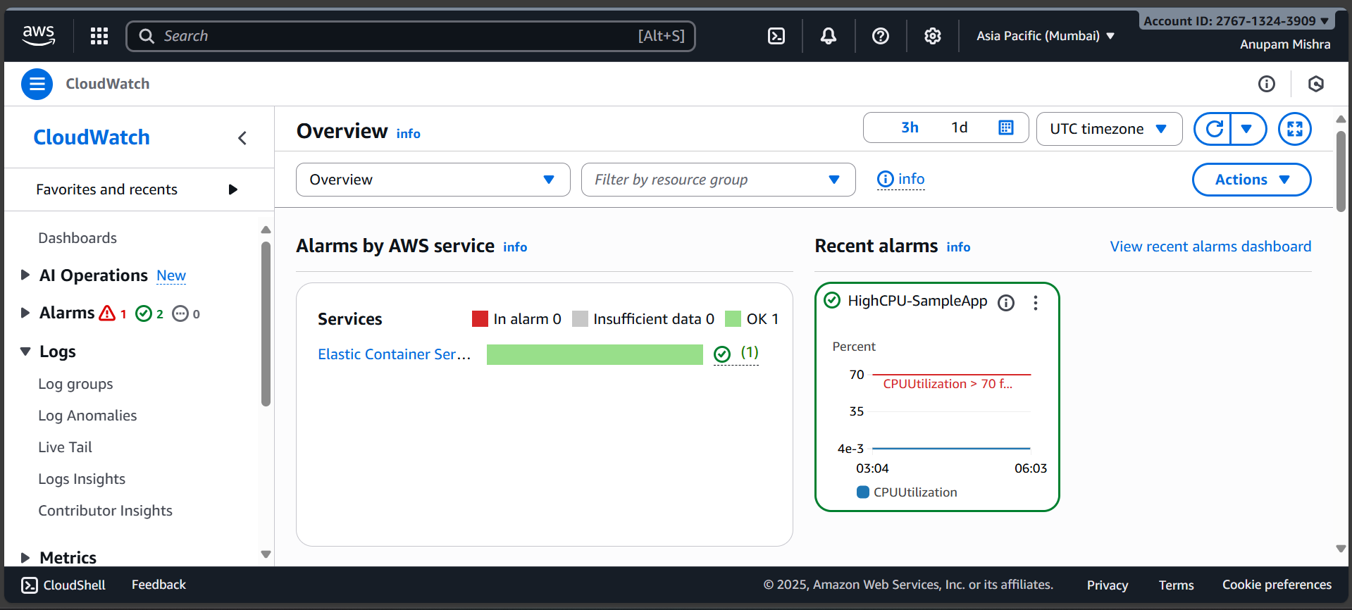

2. Navigate to Log groups and find the log group named /aws/lambda/my-first-lambda.

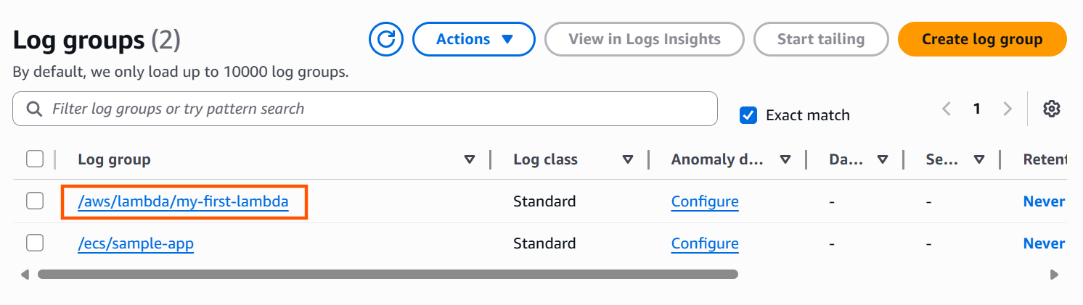

3. Open the log group and click on the log stream to see the details of your function's invocation, including the start, end, and duration.

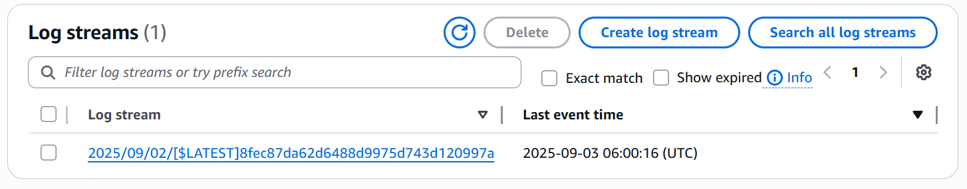

4. Go back to the CloudWatch console and click on Metrics and select Lambda to see invocation counts and errors.

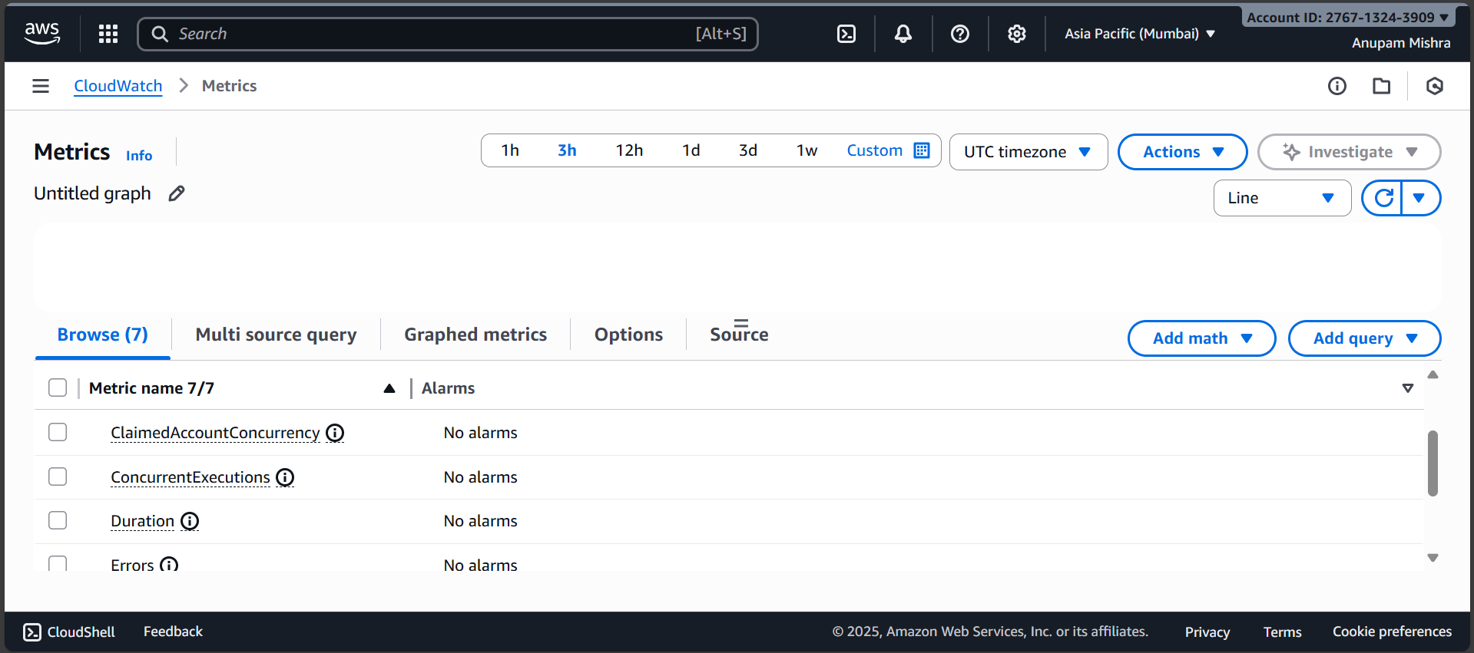

Step 6: Update the Lambda Function

Serverless functions are easy to update without downtime. Let's change our message and deploy the new code.

1. Edit the function code:

nano index.js

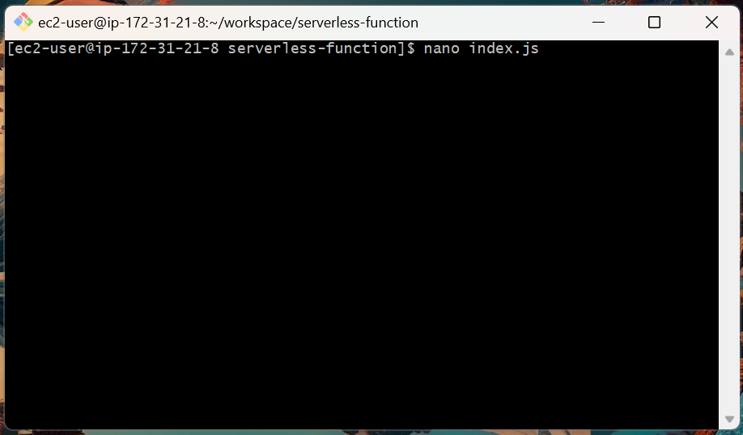

2. Change the body of the response to a new message:

exports.handler = async (event) => {
const response = {
statusCode: 200,
body: JSON.stringify('Hello from updated Lambda!'),
};
return response;
};

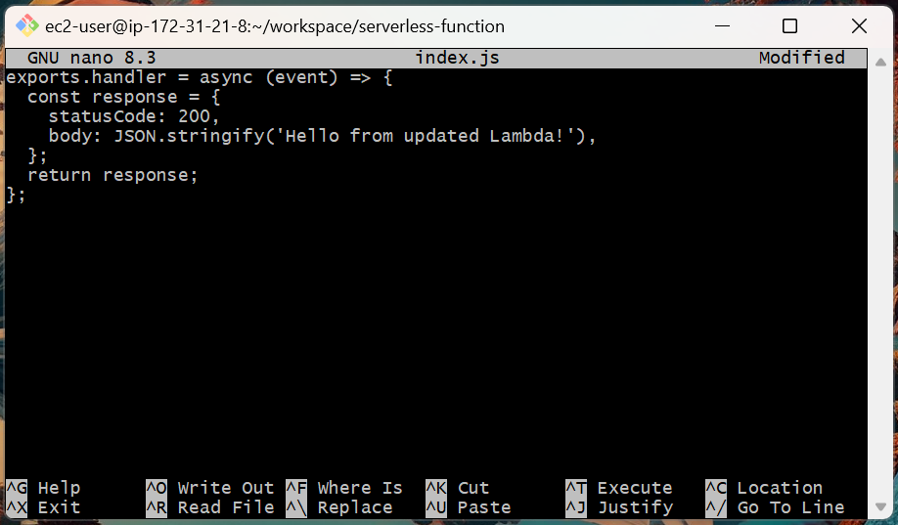

3. Save and exit.

4. Update the zip file.

zip function.zip index.js

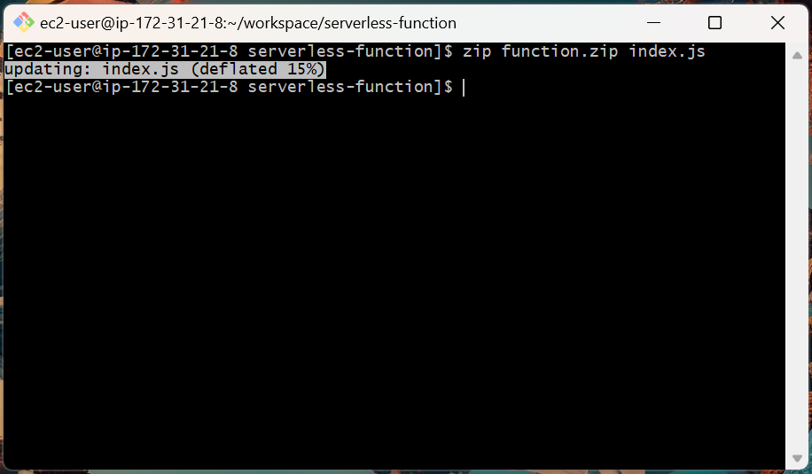

5. Use the update-function-code command to deploy the new version.

aws lambda update-function-code \
--function-name my-first-lambda \
--zip-file fileb://function.zip \
--region ap-south-1

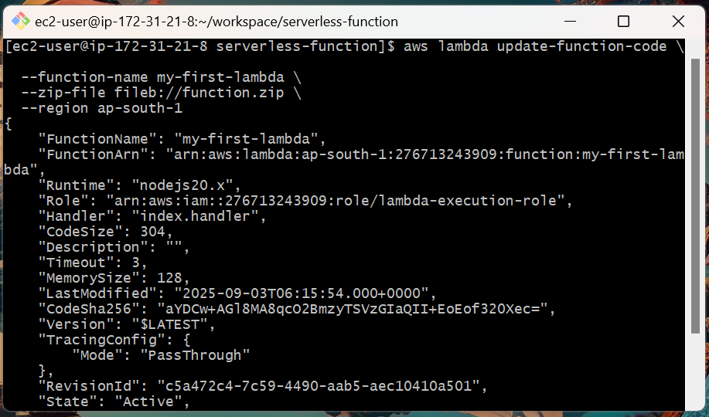

6. Invoke the function again to verify the new output:

aws lambda invoke \
--function-name my-first-lambda \
--cli-binary-format raw-in-base64-out \
--payload file://event.json \
output.json

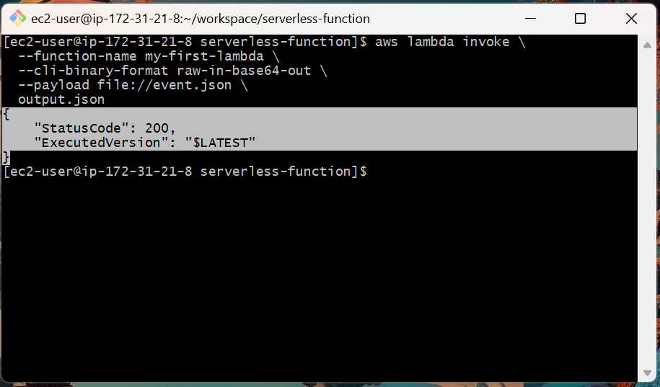

The output.json should now contain the new message.

Step 7: Clean up Resources

To avoid incurring charges, we'll remove the resources we created.

1. Delete the Lambda function:

aws lambda delete-function \
--function-name my-first-lambda \
--region ap-south-1

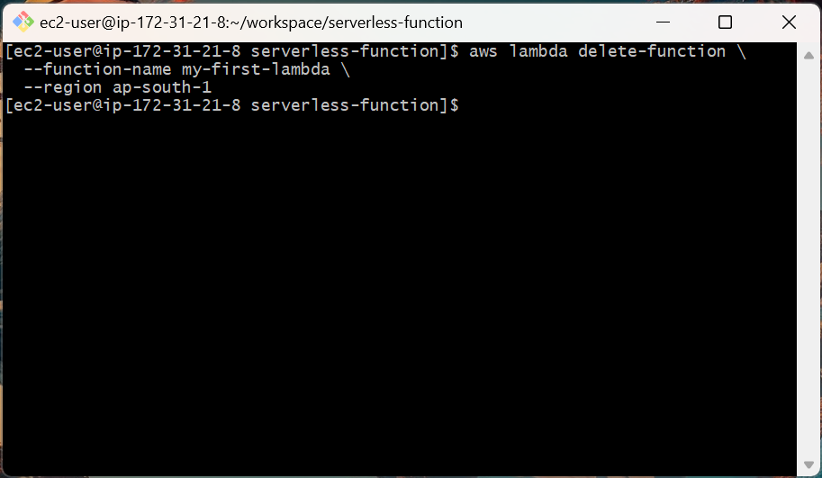

2. Detach the policy from the role:

aws iam detach-role-policy \
--role-name lambda-execution-role \
--policy-arn arn:aws:iam::aws:policy/service-role/AWSLambdaBasicExecutionRole

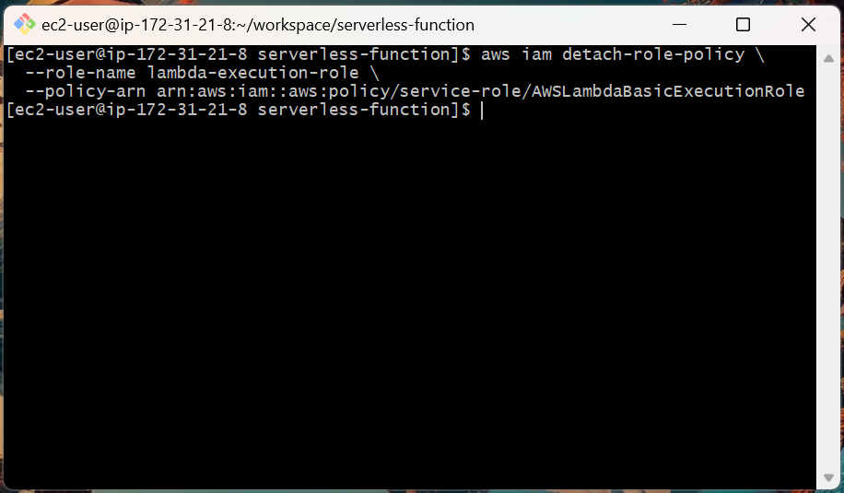

3. Delete the IAM role:

aws iam delete-role \
--role-name lambda-execution-role

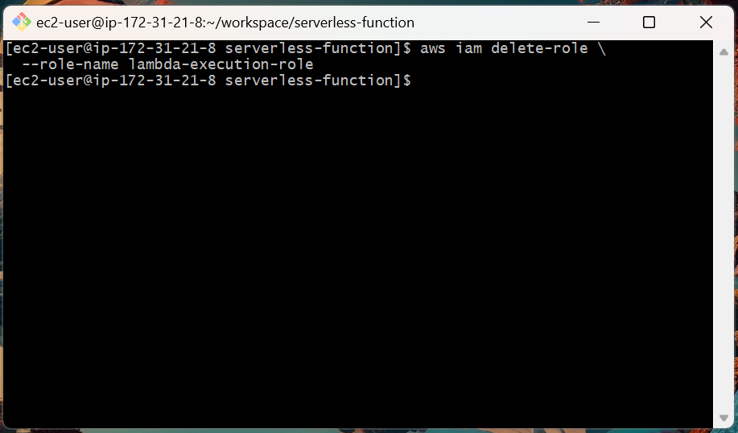

4. Delete the CloudWatch log group:

aws logs delete-log-group \
--log-group-name /aws/lambda/my-first-lambda \
--region ap-south-1

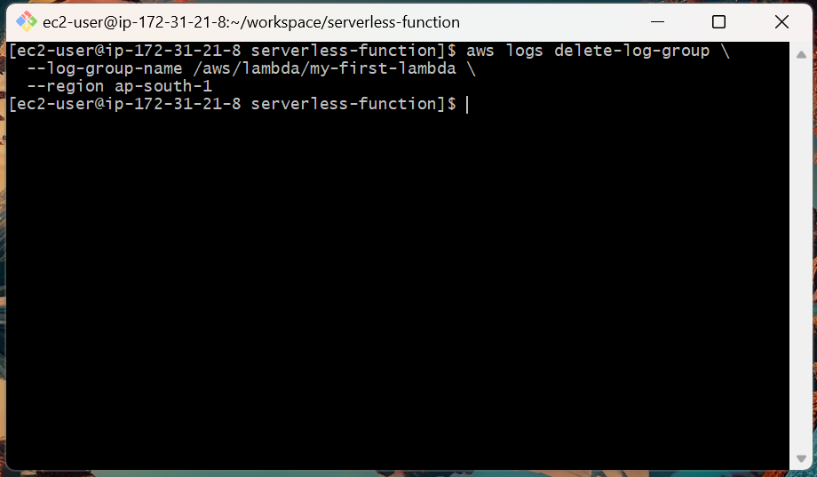

Topics Covered:

1. Created a basic serverless function.

2. Set up an IAM role for Lambda execution.

3. Deployed a function using the AWS CLI.

4. Tested a Lambda function by invoking it.

5. Monitored function logs and metrics in CloudWatch.

6. Updated and re-deployed the function code seamlessly.

7. Cleaned up all cloud resources to avoid future costs.

